

**COS10026 Assignment 1  
Static Website Report**

by Ta Quang Tung (104222196)

**Introduction**

This report presents the key features and implementation details of our jewelry-selling website as part of Assignment 1 of unit COS10026 – Computing Technology Inquiry Project. This website is a collaborative effort between me and my team the Maverick Mates, which also includes Nguyen Quang Huy, Nguyen Thanh Trung, Nguyen Tran Quang Minh, and Pham Hung Manh.

The report contains five sections. Section 1 describes the structure of the website and provides a sitemap. Section 2 illustrates some key features and enhancements of the website. Section 3 presents our design philosophies. Section 4 dives into the technical details of the site, including how HTML and CSS are used for basic requirements and enhancements. Section 5 lists my contributions to the project and offers some reflection.

**Section 1 – Website structure**

Our website consists of five static pages: (1) index.html – the home page, (2) product.html – a page featuring images and information about our jewelry products, (3) enquire.html – a page containing a form where users can send us enquiries, (4) about.html – a page containing information about our team members, and (5) enhancements.html – a page listing the enhancements we made.

All of these pages are linked together with a common navigation bar and a footer. Additional navigation links are also placed at relevant sections on some pages.

The overall structure of the website can be seen with this sitemap:

**Section 2 – Features and enhancements**

As described in the previous section, our website contains five static pages. When the user first enters the site, they are taken to our home page – index.html. This page features a striking background image, on top of which are the links to the product showcase page and to our enquiry form. Below the image are the thumbnails of three of our products which also act as links to their corresponding sections in the product page.

The product showcase page, product.html, contains all the information related to our products. Information about each product is placed within its own section, which consists of an image, a short descriptive paragraph, a bullet-point list of important details, and a few selectable options. Additional information about products is placed on a bordered panel floating to the right of the main content.

The enquiry page, enquire.html, features a form where the user can send us questions about a particular product and its options. The form contains fields for personal information, contact information, and product information. Most fields are validated against invalid inputs with HTML attributes like maxlength or pattern. As of now, pressing submit will only echo back the entered information.

The about page, about.html, presents information about individual members of the team. At the top of the page are links that jump to different members for easier navigation. Each member section has an image, a list of personal information, a schedule table as well as a few lists of personal interests.

The enhancement page, enhancements.html, outlines two enhancements we made for the assignment, which are the responsive navigation bar and mobile-specific layouts. Code snippets for each enhancement are also included.

All five of our pages share a common header navigation bar and a footer. These contain navigation links that help connect all pages together. More powerfully, the header navigation bar has been made responsive as part of our enhancements. For large enough screens, the navigation links are placed horizontally in a block. For small screens, an icon appears in place of these links, and hovering on it causes a panel containing the navigation links to slide in from the right side of the screen.

Additionally, all of our pages are entirely responsive to ensure that users of small-screen devices have a pleasant browsing experience.

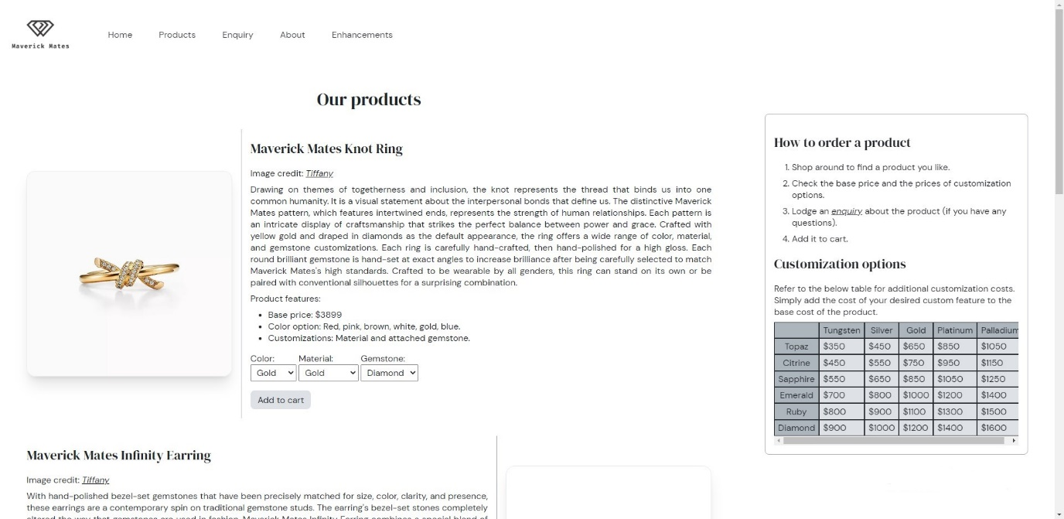

Figure 1 – Large-screen layout for product.html page.

Figure 2 – Small-screen layout for product.html page.

**Section 3 – Design philosophies**

Our website’s overall aesthetic is heavily inspired by high-end jewelry websites such as Tiffany & Co and Dior. As such, we employ a minimal color palette consisting of white, black, and in-between shades. We also choose a classy font pairing of DM Sans and DM Serif Display to convey this elegant aesthetic. These colors and fonts are used throughout the website to ensure **stylistic consistency**.

While designing the website, we also follow a number of design philosophies aside from just maintaining consistent design. **Ease of navigation** is an aspect we focus on, as reflected by the common header and footer with navigation links present across all pages. To further enhance our classy aesthetic, we try to aim for a **clean design** with appropriate layouts, borders, and shadows. Another principle, which I call **UI telegraphing**, is also applied throughout. I define it as signaling the presence of a clickable link or button with styles that distinguish it from surrounding non-interactable content. This principle is implemented through hover effects, underlines, and italicization. We also ensure that all pages are **responsive** to enhance the experience of small-screen users.

Figure 3 – Places where UI telegraphing is used. When hovered on, these links/buttons will change appearance.

**Section 4 – Implementation**

As this website is entirely static, only HTML and CSS are necessary to run it. Each page is marked up in a separate HTML file styled by a common CSS file.

All of our HTML and CSS files have been validated by <https://validator.w3.org/nu/#file> and <https://jigsaw.w3.org/css-validator/> to ensure standard conformity. We also use semantic elements like <article>, <nav>, etc. whenever possible as good practice.

The requirement of one common CSS file to style all pages presents the issue of potential conflict between styles. This problem is made worse by each member doing their own styling and not knowing what class names or IDs the others might use. To tackle this issue, we tagged the main content of each page with a unique ID that we agree not to use elsewhere, for a total of 5 IDs. When it came to writing the CSS, we prefixed the rulesets of each page with its corresponding ID to scope the CSS to that page.

*/* These styles will only apply to the product.html page */*

#product,

#product * {

    box-sizing: border-box;

    margin: 0;

    padding: 0;

}

#product * {

    font: 1em "DM Sans", sans-serif;

    color: #212529;

}

#product h1 {

    font: 2em "DM Serif Display", sans-serif;

    margin: 1em 0;

}

#product h2 {

    font: 1.5em "DM Serif Display", sans-serif;

    margin: 0.75em 0;

}

Two enhancements made to the website are mobile-specific layouts and a responsive navigation bar. Both of these features required the viewport meta tag to be present in the HTML.

<meta name="viewport" content="width=device-width, initial-scale=1.0">

For responsivity, we worked with a desktop-first approach, designing styles for desktop screens initially and then applying media queries as needed to cater to mobile devices.

*/* Media query for the mobile layout of the product.html page. */*

@media screen and (max-width: 768px) {

    #product aside,

    #product article {

        float: none;

        width: auto;

    }

    #product aside {

        margin: 2em;

    }

    #product section {

        display: block;

    }

    #product section:not(:last-child) {

        padding-bottom: 2em;

        margin-bottom: 2em;

        border-bottom: solid 1px #ADB5BD;

    }

    #product section img {

        max-width: 280px;

        margin: 0 auto;

    }

    #product section div {

        border-left: none;

        margin-left: 0;

        padding-left: 0;

    }

    #product section h2 {

        text-align: center;

    }

}

Figure 4 – Large-screen layout for index.html page.

Figure 5 – Small-screen layout for index.html page.

The responsive navigation bar involved more CSS logic. The idea of this feature is that it will present navigation links as a horizontal block for large screens and as a panel that slides in from the right on smaller screens. The navigation panel of small screens will be activated by hovering on a special icon that is hidden for large screen sizes.

The HTML for the navigation bar is presented below. Some unnecessary information has been left out for the sake of brevity. When the browser window is big enough for the large layout, the button is hidden and the #nav-container div is the same size as the <nav> block.

<header id="navbar">

  <a href="./index.html" id="navbar-logo">

    <img src="./images/logo.png" alt="logo">

  </a>

  <button id="navbar-opener">

    <svg xmlns="http://www.w3.org/2000/svg" viewBox="0 0 448 512">

      <path

        d="some path related data here..." />

    </svg>

  </button>

  <div id="nav-container">

    <nav>

      <ul>

        <li><a href="./index.html">Home</a></li>

        <li><a href="./product.html">Products</a></li>

        <li><a href="./enquire.html">Enquiry</a></li>

        <li><a href="./about.html">About</a></li>

        <li><a href="./enhancements.html">Enhancements</a></li>

      </ul>

      <p>

        &#169; Copyright Maverick Mates 2023

      </p>

    </nav>

  </div>

</header>

However, if the screen gets smaller, the button will be revealed and the div will take position: fixed and occupy the right side of the screen, acting as a view window for the <nav> to slide in/out.

#navbar #navbar-opener {

    display: none; */* Hides the button for large screens. */*

}

#navbar #nav-container {

*/* The #nav-container div is the same size as the nav. */*

width: fit-content;

}

#navbar #nav-container nav ul {

    display: flex; */* The list is laid out horizontally. */*

}

@media screen and (max-width: 44em) {

    #navbar #nav-container {

*/* The div is fixed to the right of the screen and occupies 70% of the screen width and 100% of the screen height */*

        position: fixed;

        top: 0;

        right: 0;

        width: 70%;

        height: 100vh;

*/* overflow: hidden helps the div act as a window for the nav */*

        overflow: hidden;

*/* On small screens, this nav container will be on top of the trigger button. */*

*/* pointer-events: none tells the browser to ignore mouse events on the container, allowing hover events on the button to be fired. */*

        pointer-events: none;

    }

    #navbar #nav-container nav {

*/* The nav fills the entire div and is positioned absolutely to the div */*

        position: absolute;

        top: 0;

        right: 0;

        width: 100%;

        height: 100%;

*/* By default it hidden outside the div */*

        transform: translate(100%);

        transition: all 0.2s ease-in-out;

    }

    #navbar #nav-container nav ul {

*/* The list is now vertical */*

        display: block;

    }

    #navbar #navbar-opener {

*/* Reveals the button */*

        display: block;

    }

*/\**

*This ruleset is applied to the nav container (which is a div) when:*

*- The trigger button is hovered on.*

*- The nav container is hovered on.*

*\*/*

    #navbar #navbar-opener:hover + #nav-container,

    #navbar #nav-container:hover {

        pointer-events: all;

    }

*/\**

*Slides the nav in.*

*This ruleset is applied to the nav element itself when:*

*- The trigger button is hovered on.*

*- The nav container is hovered on.*

*\*/*

    #navbar #navbar-opener:hover + #nav-container nav,

    #navbar #nav-container:hover nav {

        transform: none;

    }

}

The last two rulesets work in conjunction as follows: When the icon (in the form of a button) is hovered on, the #nav-container div will accept pointer events and the navigation will slide in. Since the div can now detect hover mouse events, and as long as the user keeps their cursor within the boundaries of the div, the nav will remain on screen. Once the user moves outside the div, the nav will collapse.



Figure 6 – The responsive navigation bar for large screens.

Figure 7 – The responsive navigation bar for small screens.

**Section 5 – Contributions and reflections**

My contributions to this project included styling the product.html page, implementing the responsive navigation bar enhancement, and ensuring that design principles are applied throughout the website.

My work on the product.html page consisted of working on the HTML scaffold provided by my teammate. To construct the layout of the page, I first worked on paper before translating my final design into CSS code. I kept special effects down to a minimum to adhere to our minimalist aesthetic.

The shared responsive navigation bar involved more experimentation as I had to make sure its appearance fitted the design of all pages. Thankfully, since the website uses a single color palette and shares a consistent feel, integrating the navigation bar into the pages was not too challenging.

As the leader of my group, I also had to make sure that everyone does not stray too far from our design principles. While providing feedback on my team’s work, I had to strike a balance between respecting their personal creativity and ensuring stylistic conformity. Fortunately, my teammates’ designs stayed well within our stylistic boundaries and there was still room for their individual expression.

This project has acquainted me with the normal workflow of designing a static website. I have learned techniques like sketching my initial design onto paper and wireframing my layout before getting down to the code. I have also learned to validate my HTML and CSS to ensure standard compliance. However, in the future, I will try to adopt a mobile-first approach to my design. At the moment, I am working from large to small screens, but it is best practice to do the opposite, starting from small screens first and scaling up.

**Summary**

This report describes the various technical and stylistic aspects of our static website as part of Assignment 1 of unit COS10026. Points covered include the structure, features and enhancements, design principles, and code implementations of the website as well as my contributions to it. The final section also suggests one potential improvement to the website: to design with a mobile-first approach.